**Image Erosion without using MATLAB function 'imerode'**

In MATLAB, ‘imerode’ is a function used to make the objects thin. MATLAB code without using 'imerode' function and explanation is provided here.

[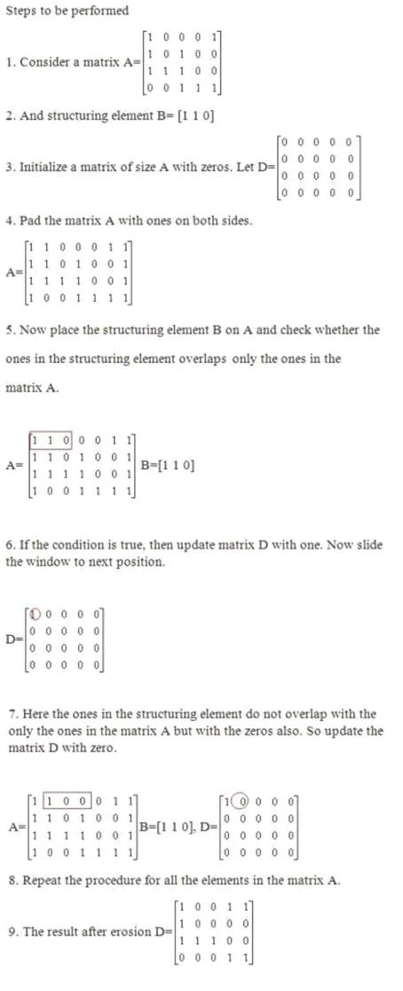](http://3.bp.blogspot.com/-ftbLF-s9Y58/UFShCK0d9pI/AAAAAAAAAtk/-J7zD8RT5QE/s1600/erosion_steps.JPG)

MATLAB CODE:

A=[1 0 1 1 1; 1 0 1 0 0; 1 1 1 0 0;0 0 1 1 1];

%Structuring element

B=[1 1 0];

%Pad array with ones on both sides

C=padarray(A,[0 1],1);

%Intialize the matrix D of size A with zeros

D=false(size(A));

for i=1:size(C,1)

    for j=1:size(C,2)-2

        In=C(i,j:j+2);

        %Find the position of ones in the structuring element

        In1=find(B==1);

        %Check whether the elements in the window have the value one in the

        %same positions of the structuring element

        if(In(In1)==1)

        D(i,j)=1;

        end

    end

end

display(D);

Explanation:

1.     Consider a matrix A and a structuring element B.

2.     Initialize a matrix D of size A with zeros.

3.     Construct a window of size B with the elements of matrix A.

4.     Check whether the ones in the structuring element B overlap the ones in the window.

5.     If it overlaps, then update D with one else zero.

Example 2:

A=imread('circles.png');

figure,imshow(A);

|  |
| --- |
| <http://1.bp.blogspot.com/-rBDi9JbqeLU/UFSbHZiQgBI/AAAAAAAAAss/hZTvSSSB0bk/s1600/circles.png> |
| Original Image |

%Structuring element

B=getnhood(strel('disk',11));

m=floor(size(B1,1)/2);

n=floor(size(B1,2)/2);

%Pad array on all the sides

C=padarray(A,[m n],1);

%Intialize a matrix with size of matrix A

D=false(size(A));

for i=1:size(C,1)-(2*m)

    for j=1:size(C,2)-(2*n)

        Temp=C(i:i+(2*m),j:j+(2*n));

        D(i,j)=min(min(Temp-B1));

    end

end

figure,imshow(~D1);

|  |
| --- |
| <http://3.bp.blogspot.com/-UfNOTBA60HI/UFSbMhBxiaI/AAAAAAAAAs0/LCkem4cKkBQ/s1600/image_erode.jpg> |